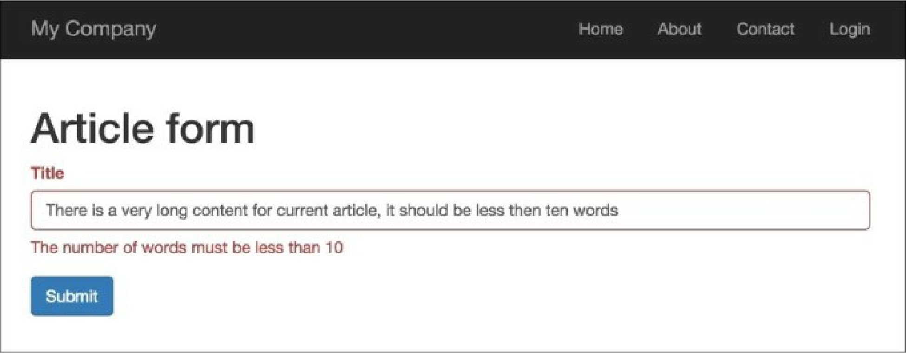

If you enter fewer than ten words, client-side validation will be successful:

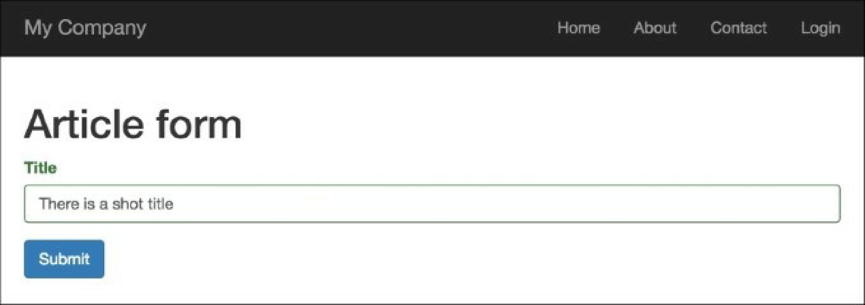

First, we created @app/components/wordsvalidator. php, which extends the

@yii\validators\validator class, and added the newly-created validator class to the title attribute of the Article model:

['title', WordsValidator::className(), 'size' => 10],

Inside our validator, we’ve defined two special methods: validatevalue() and clientValidateAttribute().